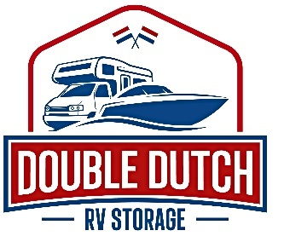 | Double Dutch RV Storage  23173 Range Road 213  Ardrossan,AB T8G 2C3  (780)499-3302  Doubledutchrv@gmail.com

Generator Rental Contract : 4250 Watt Generator

Renter Name:
Address:
Phone Number:
Credit Card :_________________________________ Expiry ______/_________

Rental Period:

Terms of Agreement:
- Rental fees must be paid prior to rental.

- Generator must be returned on the last day of the rental period. Please lock up the generator to your trailer and send a text to (780) 499 – 3302 so we are aware and ready to pick up. Additional fees will be accrued every day the generator is not returned, following the end of the contract. The client is responsible for these payments.

- A credit card on file is required. The Card on file will be charged $1000 if generator is not returned.

- The generator requires gas to run – this is the responsibility of the renter.

Lisa Vander Heide
General Manager Double Dutch RV Storage
(780) 499-3302
Doubledutchrv@gmail.com

Terms & Conditions
- Double Dutch RV will not accept liability for damage or loss of the generator. It is the renters responsibility to return it in the condition it was rented it, and ensure its return.

- We will not accept any liability for any personal injuries, or damage to renters property as a result of the generator rental.

- Generators can be a source of danger. For this reason they must be operated strictly in accordance with the manufacturer’s instructions provided and in a safe manner at all time. We will not accept any liability for any safety issues surrounding the generator.

